TEACHER
OF THE
YEAR

William Barkley
Chairman

Telephone: 443-359-2402

Email: bbillyb69@gmail.com

Post Teacher Entry
Make a copy for each category winner.

Post Winners Section

First Name __________________________ M.I._____ Last Name __________________________________

Address/PO Box (City, State, Zip) ____________________________________________________________

Home Phone ( )________ Social Security Number ______________Grade level you teach K-5 06-8 09-12

Name of School___________________________________________ School's Phone ( ) ______________

School's Address/PO Box (City/State/Zip) ______________________________________________________
Post winner must provide a one page resume (no more than two sides), up to 5 pages of documentation (news articles or supervisors recommendations) and a good quality head and shoulders photo (no color copies or low grade computer printouts) to substantiate his/her nomination to the Post Chairman who will forward the packet to District Chairman.

Post and Auxiliaries Chairman Section

I certify that the teacher named above is the duly selected Post winner of the National Citizenship Education Teacher Award Program in his/her grade level category and is our Post's authorized entry into the District finals. Deadline: On or about November 15, 2017 to District Chairman/designated District representative.

Signature of Post Commander/Chairman _________________VFW Post No. ______ Phone ( ) _________

Post Address/PO Box (City/St/Zip) ____________________________________________________________

Signature of Auxiliary President/Chairman ___________________ Auxiliary No.____ Phone ( ) _________

Auxiliary Address/PO Box (City/St/Zip) _________________________________________________________

Total number of schools participating: _____. Total number of teacher nominations for all categories: ______.

Total dollar amount spent by Post and Auxiliary for awards for all categories (citations, gifts, etc.) $_________

District / Auxiliary Chairman Section

I certify that the teacher named above is the duly selected District winner of the National Citizenship Education Teacher Award in his/her grade level category and is our District's entry into the Department finals. Deadline for all District entries to Department is December 15, 2018. Must include the Post winner's original application, essay, resume and up to five pages of documentation and a good quality head and shoulders photo (no color copies or low grade computer printouts).

Signature of VFW Dist. Commander/Chairman _________________ Dist. No._____ Phone ( ) __________

Address/PO Box (City/St/Zip) ________________________________________________________________

Signature of Auxiliary Dist. President/Chairman ________________ Dist. No.______ Phone ( ) __________

Address/PO Box (City/St/Zip) ________________________________________________________________

Total number of schools participating: ______. Total number of teacher nominations for all categories ______

List all Posts participating in program: _________________________________________________________

Total dollar amount spent by Posts/Auxiliaries for awards for all categories (citations, gifts, etc.) $__________

VFW Department Commander/Chairman Section

I certify that the teacher listed above is the duly selected winner of the 2017 - 2018 National Citizenship Education Teacher Award in our Department in his/her grade level and is our sole official entry into the National judging. January 15, 2018 is the deadline for all Department entries to National Citizenship Education Department. VFW National Headquarters, 406 W 34 St. Kansas City, MO 64111. No extensions permitted.

I hereby certify that our teacher HAS BEEN or WILL BE (circle one) notified that they are the first place state

winner in their grade level on the following date: ________________________________________________

REMEMBER:

National Headquarters will contact your winner and Department Adjutant if he/she is selected as the National Winner.

Signature of Dept. Commander/Chairman _______________________________ Phone ( ) _________

Address/PO Box (City/St/Zip)______________________________________________________

Note: Be sure this form is entirely completed before sending to National Headquarters with your state
winner's original nomination form, essay, one page resume, up to five pages of documentation and a
good quality head and shoulders photograph (no color copies or low grade computer printouts). Remember this form is due back to VFW National Headquarters Citizenship Education Department by January 15, 2018.



TEACHER OF THE YEAR
2017 – 2018

Nominations process:

- Nominations to be no more than 350 words

- No self nominations

- Previous Department winners are not eligible

- Must have entry form

- Must have original entry form

- Teacher’s resume may not be more than (1) page (both sides)

- May have up to (5) pages of documentation (both sides)
- News articles
- Supervisors recommendations
- Awards
- Other

- A good head and shoulders photograph

Deadlines:

Post November 1st 2019 Nominations

District November 15th 2019 Nominations

Department December 15th 2019, Nominations

Further information or assistance:

William Barkley, Chairman
VFW Teacher of the Year
113 Diamond Avenue
Salisbury, MD 21804

Telephone: 444-359-2502

Email: bbillyb69@gmail.com

TEACHER OF THE YEAR

The Veterans of Foreign Wars launched the National Citizenship Education Teacher of the
Year Award in 1999 to recognize classroom teachers for promoting citizenship education with their
students. Each National award teacher winner and his/her school receives $1,000 Past Commander
-in-Chief John Smart award and a plaque. Brochures are mailed to school principals at all levels and
Post Commanders in the spring. The brochure can be ordered from VFW Emblem and Supply..

Communicate All Deadlines:

Deadline for teacher nominations is November 1. Post judging should be completed from November 2 – 15. District judging must be completed by December 15, and judging by Departments must be completed by January 10. It is extremely important that the winning entries at the Post level be submitted to the District and then the District winners forwarded to the Department in a timely manner.

Post Chairmen must be sure to send the original nomination form, essay and official Post teacher entry from of the winner from each grade’s category level – along with a one-page resume, up to five pages of documentation and a good quality head and shoulders photograph from the winning teachers – to their District chairman. This must be done at least five days prior to the announced date of the District judging deadline. Note: Posts are not required to have a winning entry at each grade’s category level.

Previous state and national VFW winners are not eligible.

Judging:

Select competent and unbiased judges. A panel of at least three to five judges is always recommended. The VFW chairman should be present at the judging to provide assistance but should not be one of the judges. One important job of the chairman at this stage is to review all nomination forms to ensure they adhere to the rules. Make sure entry is not a self nomination. The nominator should keep to the 350 word limit and sign the nomination.

Judges should grant points based on three criteria: Innovative approach to teaching citizenship (1-50 points); Development of resources to teach citizenship education (1-25 points); and Compassion to teaching citizenship education (1-25 points).

Running the Program:

Here are some important points to remember when conducting the National Citizenship Education Teacher of the Year Award program:

Know the program procedures and judging guidelines thoroughly

Develop a good working relationship with your Post’s Ladies and Men’s Auxiliary chairmen

Contact schools early and make a point of explaining the importance of the program to the
Principal

Send a news release to your local media with the names of your winning teachers.

Recognize your participants – both winners and judges – with official VFW awards (see the official VFW Emblem and Supply Department catalog for ideas). Send an accurate and detailed report to your competition along with your winning Post’s entries to the District as soon as the competition is finished. Your report should include: Ladies and Men’s Auxiliary participation; the number of schools that had nominated teachers; and the total amount of money spent (including banquet costs, gifts and citations). See the Official Post Teacher Entry form in this handout.

Teacher Award Judges Score Sheet
Photocopy this form as necessary

Contestant’s Last Name | Innovative Approach  to Teaching  (1-50 Points) | Development  of Resources  (1-25 Points) | Compassion to  Teaching  (1-25 Points) | TOTAL  (100 Points  Max)

Date ___________ Post #. ________ Judge’s Signature ___________________ Grade Level K-5; 6-8; 9-12

National Citizenship Education Teacher Award Guidelines:

Know the Program:

Post and Auxiliary Chairmen should become completely familiar with the Teacher Award guidelines. Read the program brochure and these guidelines thoroughly.

Coordinate with the Auxiliary:

The Post Chairman should have or develop a good working relationship with the Auxiliary Chairmen. Meet with the chairmen to plan a course of action and clearly determine duties and responsibilities.

Distribution of Brochures:

We launch this program in the spring with a mailing of a program brochure. The brochure contains basic program information designed to interest individuals in nominating a teacher. The brochure mailing is made to elementary, junior high/middle and high schools. It is also mailed to VFW Commanders and Auxiliary Presidents. The nomination brochure is available from VFW Emblem and Supply, 816-821-2606.

Contact Schools:

A personal contact is the best way to develop a good working relationship with the school. Ask the principal to distribute information to all teachers. Contact the local Board of Education and ask for their assistance in conducting this contest.

Contact the Local Media:

Visit or call the Program Director/Editor of your local radio/TV stations and newspapers. Invite local media to assist with the judging. Media locations have meeting rooms which are excellent for judging.

Reporting Requirements:

It is the responsibility of Chairmen at all levels to keep accurate records of participation. The participation information should be forwarded from the Post to the District and then the Department so that each Department Chairman can prepare a consolidated report and send it to National Headquarters. The appropriate final form for Department reporting is mailed directly to each Department for their Chairman from National Headquarters.

Judging:

Chairmen at all levels should never pre-judge the competitors. Judging is the responsibility of the judges. Chairmen should review the entries (if time permits) prior to the judging to make sure the entry is following the basic guidelines. Make sure the entry is not self nominated. Check the word count to make sure it is 350 words or less. Separate you entries into their appropriate grade levels before judging.

Program score sheets will be used at all levels. Each essay should be judged on the basis of: Innovative Approach to Teaching Citizenship (1-50 points); Development of Resources to Teach Citizenship Education (1-25 points); and Compassion to Teaching Citizenship Education (1-25 points). Judges should review the blank score sheets prior to reading the entries.

Judging should take place in a room void of outside distractions. Only the Chairman (no audience) and the judges should be in the room. The judges will declare the winner based on the best score. In case of a tie, immediately hold a run-off. Judges decisions are final.

Department Competition:

All first place District winners’ original nomination entry, essay, completed official teacher entry Post form, a resume, and up to five pages of documentation (news articles, supervisors recommendations, etc.) and head and shoulder photograph should be in the possession of the VFW Department Chairman or representative prior to the date set for the Department judging. Department Chairmen shall notify their Districts of the exact date of the judging. The Department competition should be scheduled between December 16 and January 10. All Department competitions must be completed by January 15.

Departments should forward the top winning entries to National Headquarters on or before January 15. All entry packets should contain the original nomination form, essay, a completed Post entry form, a resume (not more than two sided), up to five pages of documentation, and a good quality head and shoulder photo of the winner.

Recognition:

Winners and judges should receive recognition for their efforts, i.e., Teacher’s Recognition Citation and Plaque. See your VFW Emblem and Supply catalog for other awards.

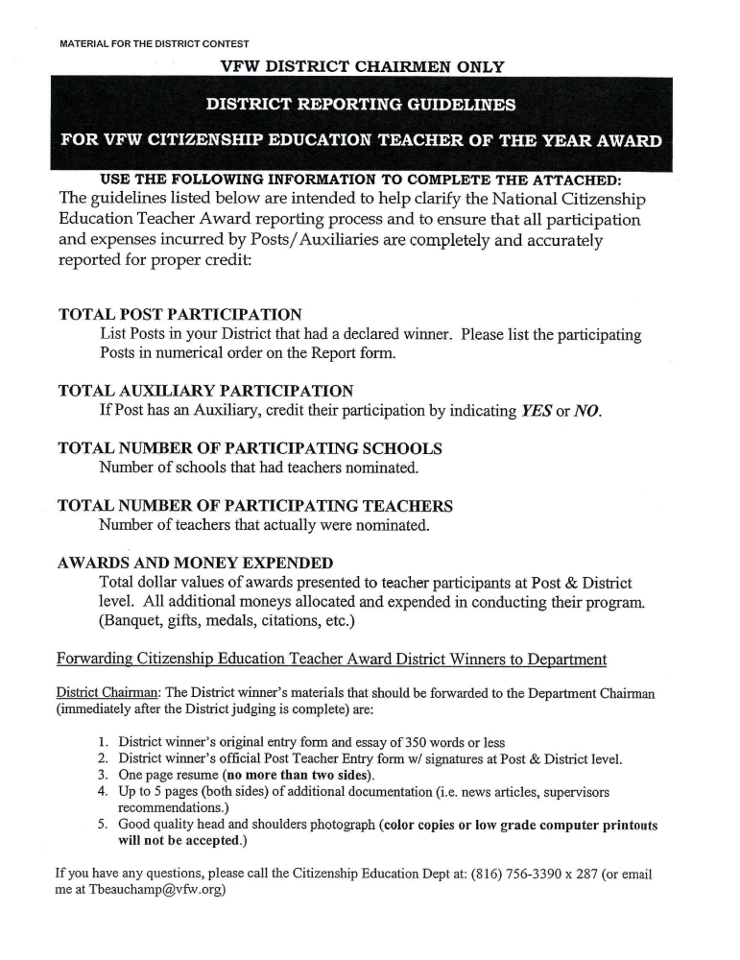

2017 - 2018 DISTRICT
CITIZENSHIP EDUCATION AWARD
TEACHER OF THE YEAR AWARD
PARTICIPATION SUMMARY REPORT

District No. ______

Department of Maryland

The VFW Posts and Auxiliaries identified in this report participated in the annual Citizenship Education Teacher of the Year Award Program.

GRAND TOTALS FOR POST COMPETITION: (List totals taken from District Report forms)

__________ __________ _____________________ ___________________
Posts Auxiliaries Participating Schools Nominated Teachers

$_______________
Awards Amount

MONETARY VALUE OF DISTRICT COMPETITION

District Awards $_________________

District Additional Expenses $_________________

GRAND TOTAL (Posts + District) $_________________

Signature _______________________________ Date_____________
(District Commander/Chairperson)

Please note – The Report Form and this summary sheet must be FORWARDED TO THE Department CHAIRPERSON IMMEDIATELY following the completion of your District Judging!
2017 - 2018 DISTRICT
TEACHER OF THE YEAR AWARD
REPORT FORM

POST NO. | AUX NO. | NUMBER OF PARTICIPATING  SCHOOLS | NO. OF  TEACHERS  NOMINATED | TOTAL DOLLARS  EXPENDED

